**Name: Vyshnav suresh**

**Roll No:56**

**Batch: MCA -B**

**Date:4/04/22**

**NETWORKING&SYSTEM ADMINISTRATION LAB**

**Experiment No.: 5**

**Aim**

Familiarization of basic linux commands

**Procedure:**

1.$**cp filename1.txt filename2.txt–** cp command used to copy

**output:**

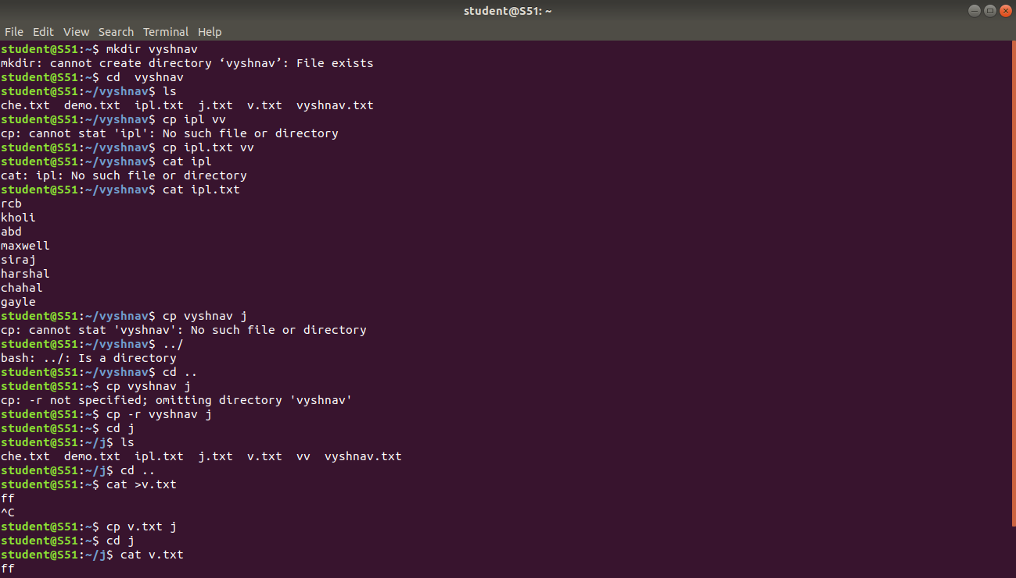

2. $**cp -r directory1 directory2**  - cp -r command is used to copy entire directory.

**output:**



**3. $cp -i filename.txt directory**– this command is used to ask permission to overwrite

**output :**



4.**$mv filename.txt directory** – mv command is used to move a file to another directory

**output:**

**5.$mv -i filename.txt directory -** this command is used to ask permission to move one directory to anotherdirectory .

**output:**